Data Structures and Algorithms: Programming Assignment
Course: MBA. Tech CE (Div-A)– Semester III
Subject Code: 702CO1C001
Instructor: Dr. Nitin Choubey
Submission Deadline: 01st November 2025
Mode of Submission: Submit GitHub repo link or PDF with screenshots and code as submission for this.

Objective
To strengthen your understanding of core data structures and algorithms by solving real-world problems on competitive programming platforms. This assignment will help you develop problem-solving skills, optimize code, and prepare for technical interviews.

Platforms
You may use any of the following platforms:
- LeetCode
- CodeChef
- HackerRank
- GeeksforGeeks Practice
Assignment Task: Data Structures Practice
Solve any two problems from the mentioned categories,
- Array
- Linked List
- Stack
- Queue
(Note: if you are chosen first problem from the Array, then the second problem should be from the other three categories)
Submission Guidelines
- Create a GitHub repository named DSA_Assignment_YourName
https://github.com/70472400346/DSA_Assignment_Sarthak
LINK OF GITHUB REPOSITORY
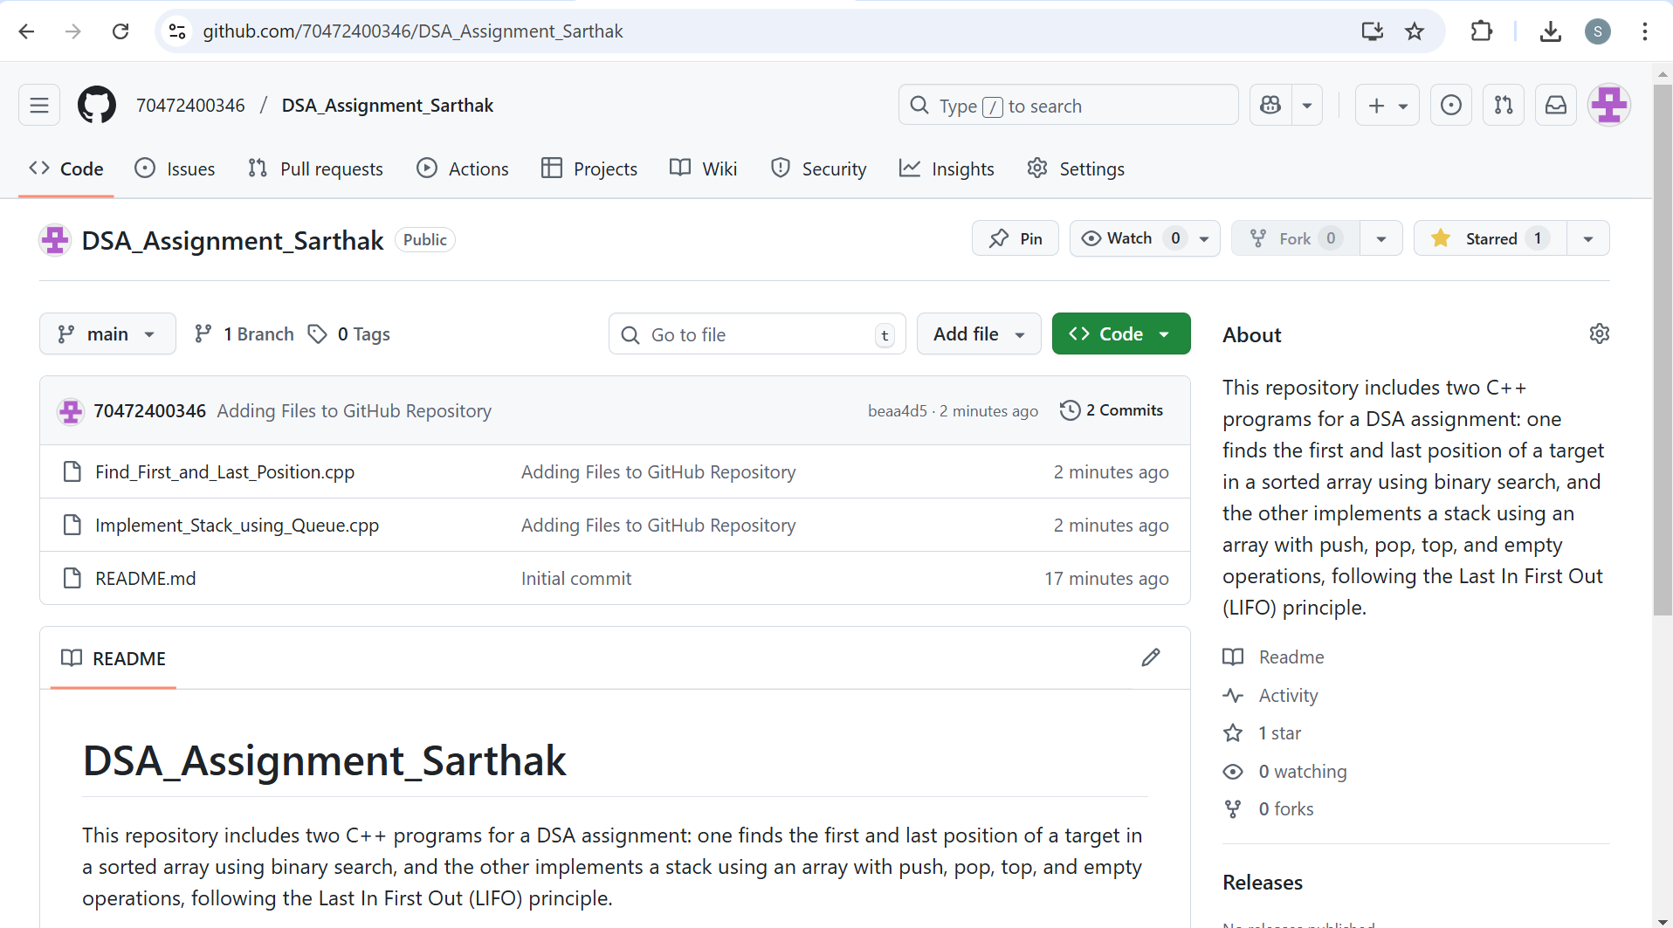
- For each problem, include:
  - Problem link
These is first array question problem link:-
https://leetcode.com/problems/find-first-and-last-position-of-element-in-sorted-array/solutions/7318334/using-cpp-solved-find-first-and-last-pos-73q7
These is second stack question problem link:-
https://leetcode.com/problems/implement-stack-using-queues/solutions/7318370/using-cpp-implemented-stack-using-queue-7thdg

  - Your code (with comments)
1.First question code:-
class Solution {
public:
vector<int> searchRange(vector<int>& nums, int target) {
int n = nums.size(), first = -1, last = -1;
int low = 0, high = n - 1;

// Binary search to find the first occurrence
while (low <= high) {
int mid = (low + high) / 2;
if (nums[mid] == target) {
first = mid; // record index
high = mid - 1; // move left to find earlier index
} else if (nums[mid] < target)
low = mid + 1;
else
high = mid - 1;
}

low = 0; high = n - 1;
// Binary search to find the last occurrence
while (low <= high) {
int mid = (low + high) / 2;
if (nums[mid] == target) {
last = mid; // record index
low = mid + 1; // move right to find later index
} else if (nums[mid] < target)
low = mid + 1;
else
high = mid - 1;
}

// Return both positions
return {first, last};
}
};
2.Second question code:-
#include <queue>
using namespace std;

class MyStack {
queue<int> q;
public:
MyStack() {} // constructor

// Push element x onto stack
void push(int x) {
q.push(x); // add new element
int size = q.size();
// rotate the queue to make the new element front
for (int i = 0; i < size - 1; i++) {
q.push(q.front());
q.pop();
}
}

// Removes the element on top of the stack and returns it
int pop() {
int topElement = q.front();
q.pop();
return topElement;
}

// Get the top element
int top() {
return q.front();
}

// Returns whether the stack is empty
bool empty() {
return q.empty();
}
};
  - Screenshot of successful submission
First successful submission of array question screenshot

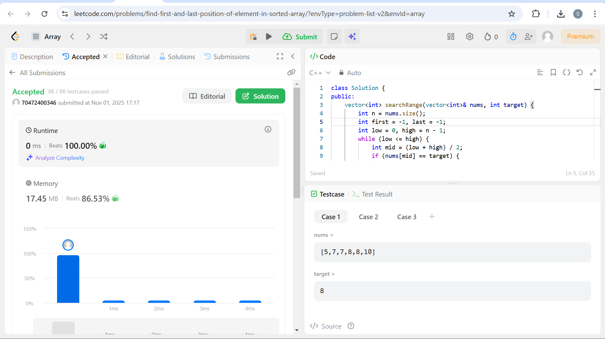
Second successful submission of stack question screenshot
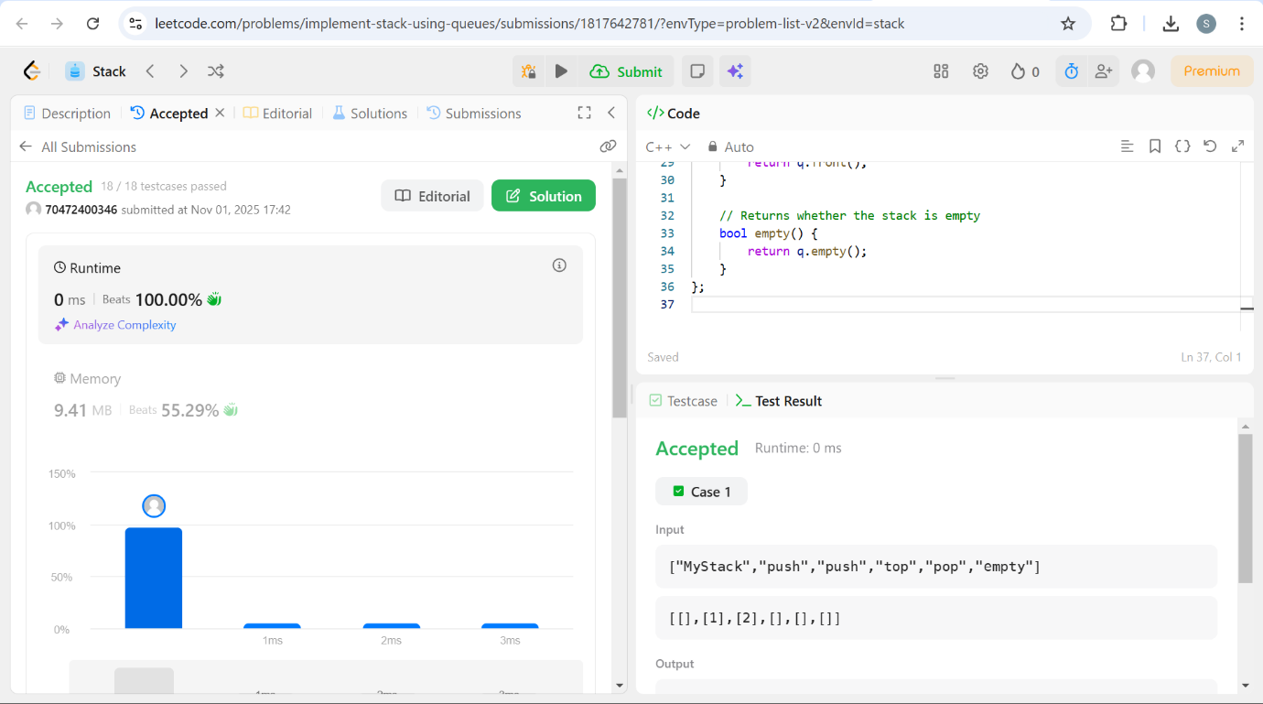
  - Brief explanation of your approach (2–3 lines)
First question approach:-
I have performed two separate binary searches:
1. Move the “high” pointer left when we find the target to locate the first occurrence.
2. Move the “low” pointer right when we find the target to locate the last occurrence.
If the element isn’t found it returns [-1, -1].
Second question approach:-
In this program, we build a stack using a simple array. A stack works on the Last In First Out principle which means the element that is inserted last will be removed first. We keep track of the top position of the stack using a variable called "topIndex". At the beginning, when the stack is empty, "topIndex" is set to "-1".
When we push a new element, "topIndex" increases by one and the element is stored at that position in the array. When we perform a pop operation the element at the current "topIndex" is removed and "topIndex" decreases by one. The top function only shows the element at "topIndex" without removing it. The empty function checks whether "topIndex" is equal to "-1" which means the stack is empty.

- Alternatively, compile all of the above into a single PDF and upload it to MS Teams.
Evaluation Criteria
- Completion of required problems
- Code correctness and efficiency
- Clarity of explanations
- Proper submission format

